Course: CSN 405 – Network Programming
LAB 10 – Async Server and Log Processing with AWK

Student name | Phan Ngoc Hanh Nhi
Student ID | 2131209002

Question 1 – User Login Verification Server
Write a Python program using asyncio that acts as a login verification server and its client.
Requirements:
The server stores the following user accounts:
users = {
"Your_name": "123456",
"user2": "network",
"user3": "python"
}
The client sends: USERNAME PASSWORD
Examples: “Your name” 123456

The server processes the request as follows:
- If the username exists and password is correct, return: LOGIN_SUCCESS
- Otherwise return: LOGIN_FAIL

The server must log each request into server.log as:
[TIME] PORT USERNAME RESULT
Example:
[2026-06-01 10:00:01] 55001 “Your name” LOGIN_SUCCESS
[2026-06-01 10:00:15] 55002 user2 LOGIN_FAIL

Write a shell script using awk to analyze server.log and automatically executes:
- Check if server.log exists.
- Total number of login requests.
- Number of successful logins.
- Number of failed logins.
- List unique usernames.
- Print usernames that have at least 3 failed login attempts.
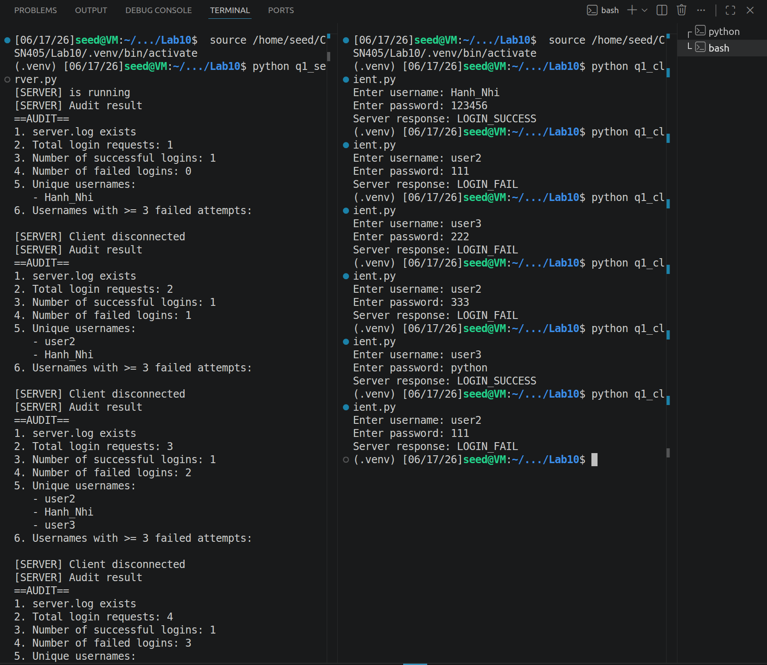
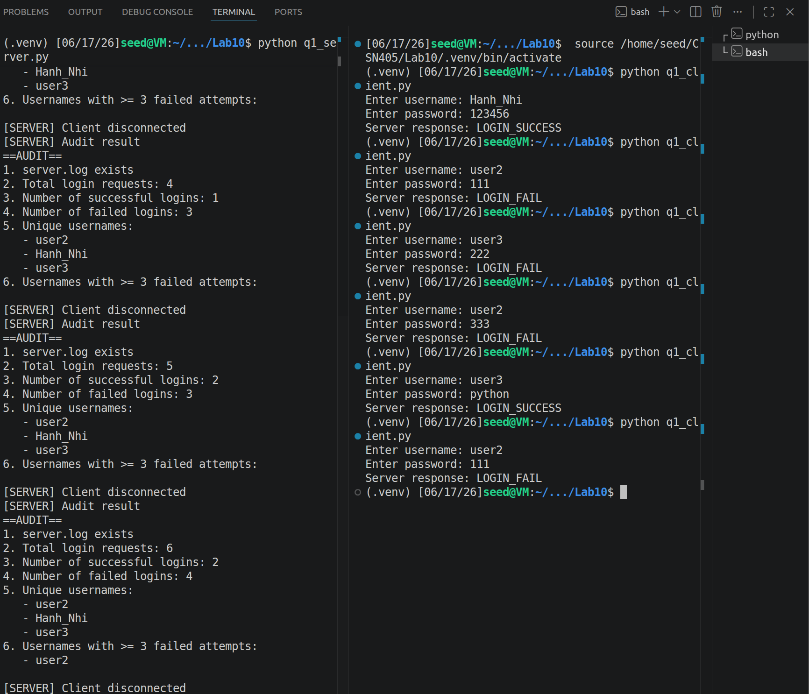

Question 2 – Password Strength Checking Server
Write a Python program using asyncio that acts as a password-strength checking server and its client.
The client sends a password string to the server.
The server processes the request as follows:
- STRONG if:
  - length ≥ 8
  - contains at least one uppercase letter
  - contains at least one lowercase letter
  - contains at least one digit
Otherwise return: WEAK
The server must log each request into server.log as:
[TIME] PORT PASSWORD RESULT
Example:
[2026-06-01 10:10:01] 55001 Abc12345 STRONG
[2026-06-01 10:10:20] 55002 abc WEAK
When a client disconnects, the server using awk and automatically executes:
- Check if server.log exists.
- Total number of password checks.
- Number of STRONG passwords.
- Number of WEAK passwords.
- Longest password received.
- Average password length.
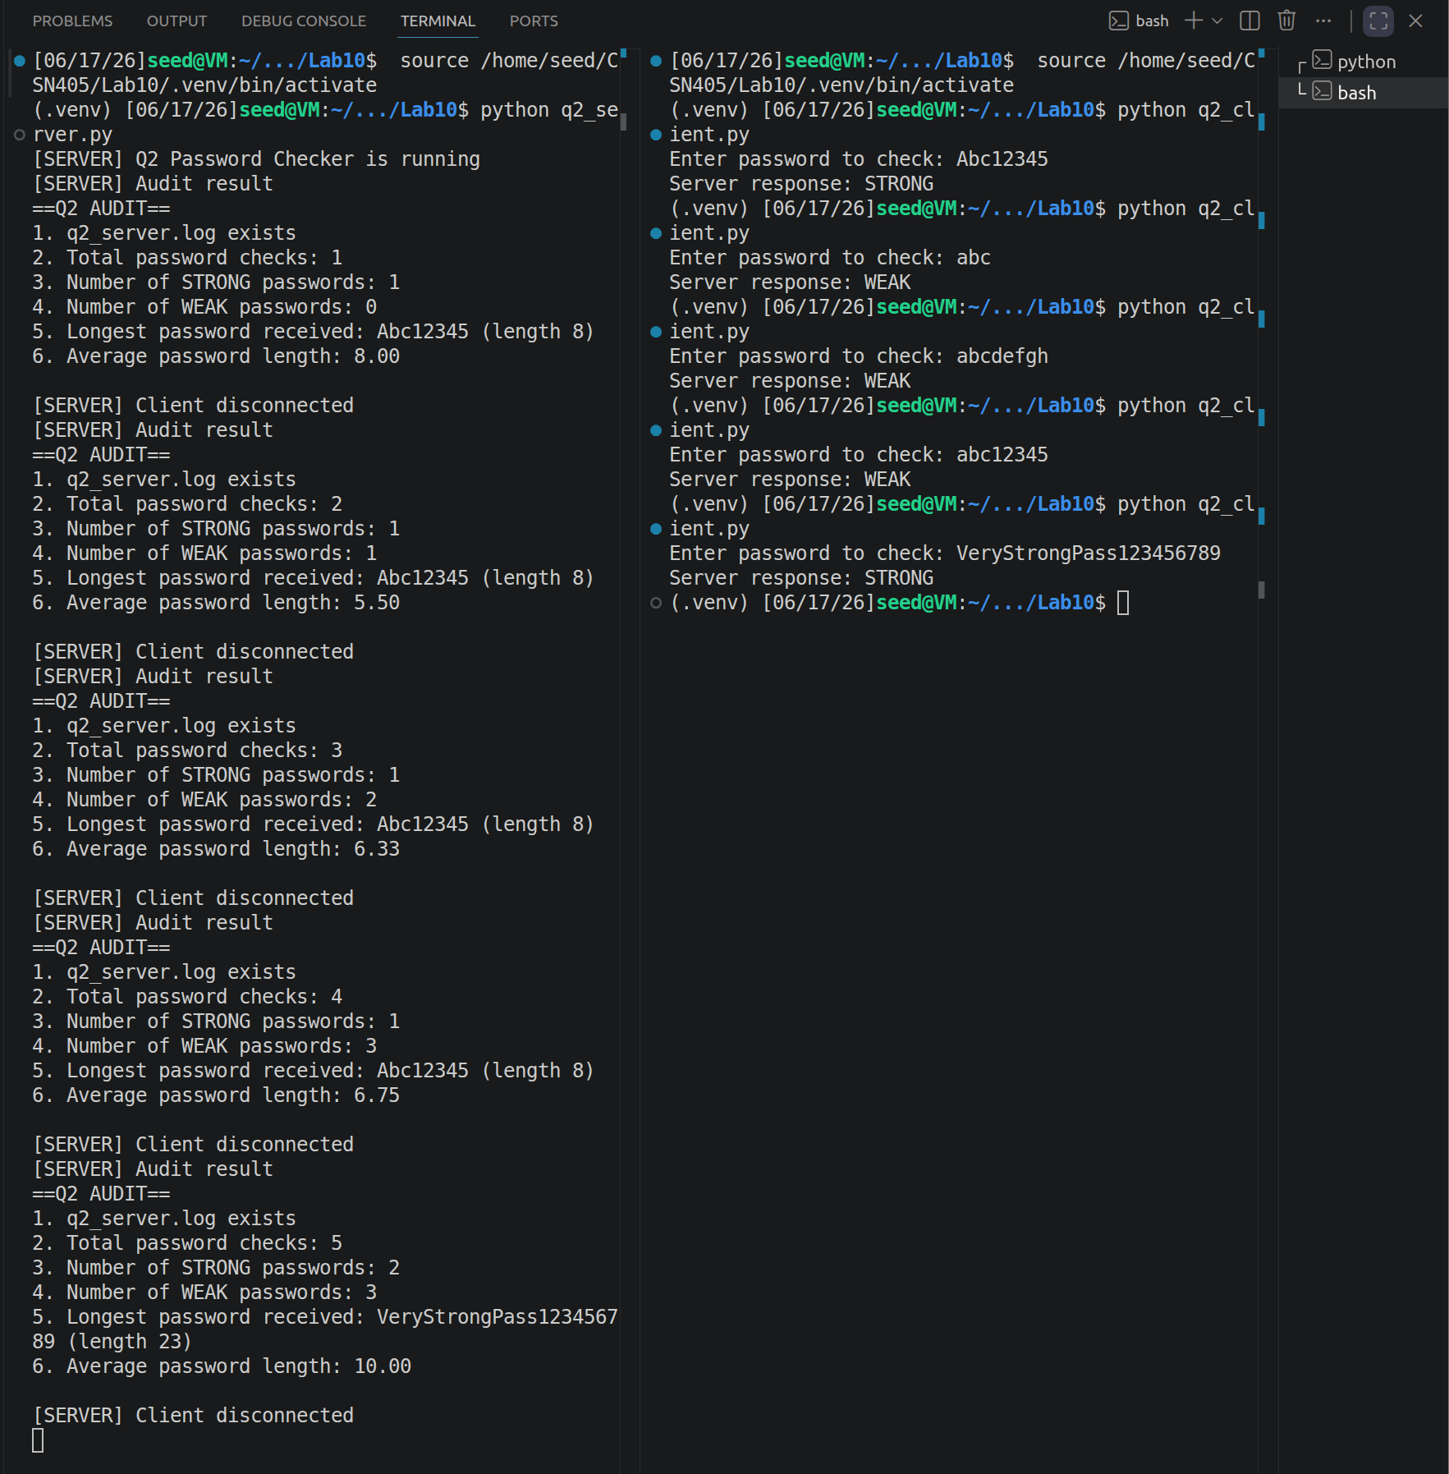
Question 3 – Student Grade Classification Server
Write a Python program using asyncio that acts as a student grade classification server and its client.
The client sends a score.
Examples: 8.5
6.2
The server processes the request as follows:
Score | Result
>= 8 | EXCELLENT
>= 6 | GOOD
>= 5 | AVERAGE
< 5 | POOR
- If the input is not numeric: INVALID
The server must log each request into server.log as:
[TIME] PORT SCORE RESULT
Example:
[2026-06-01 11:00:01] 55001 8.5 EXCELLENT
[2026-06-01 11:00:15] 55002 abc INVALID
Write a shell script using awk to analyze server.log and print:
- Check if server.log exists.
- Total number of requests.
- Number of INVALID inputs.
- Average valid score.
- Count how many students belong to each classification.
- Highest valid score.
